**Data Base [COMP122-M2020-Assignment 4]**

Shankar Sigdel - 301110925

**Table: Store_Reps**

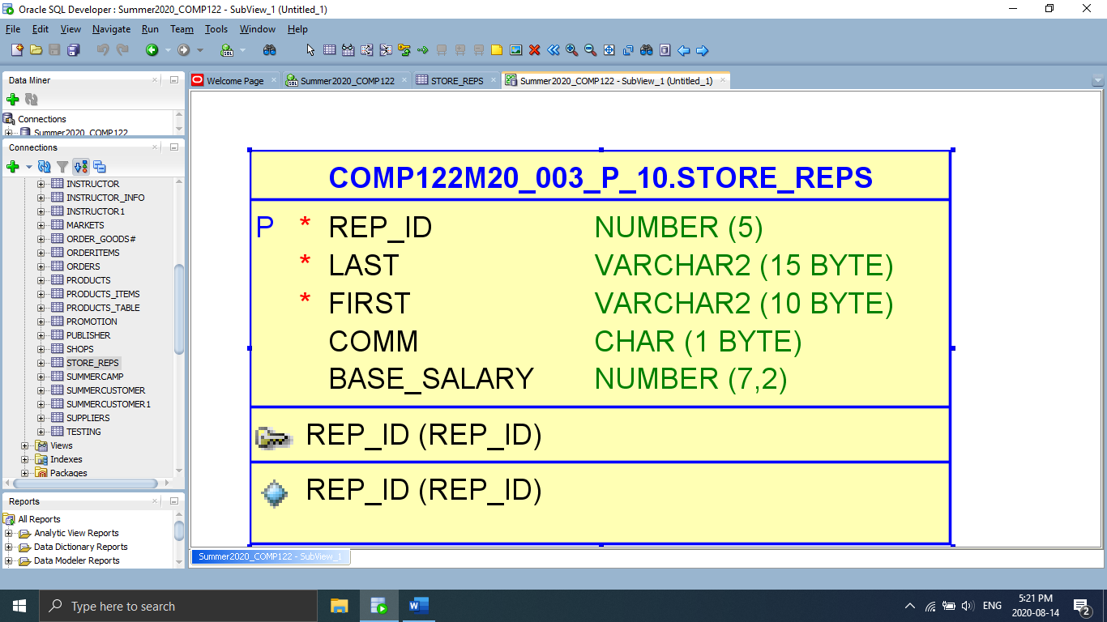

**Table: Brand**

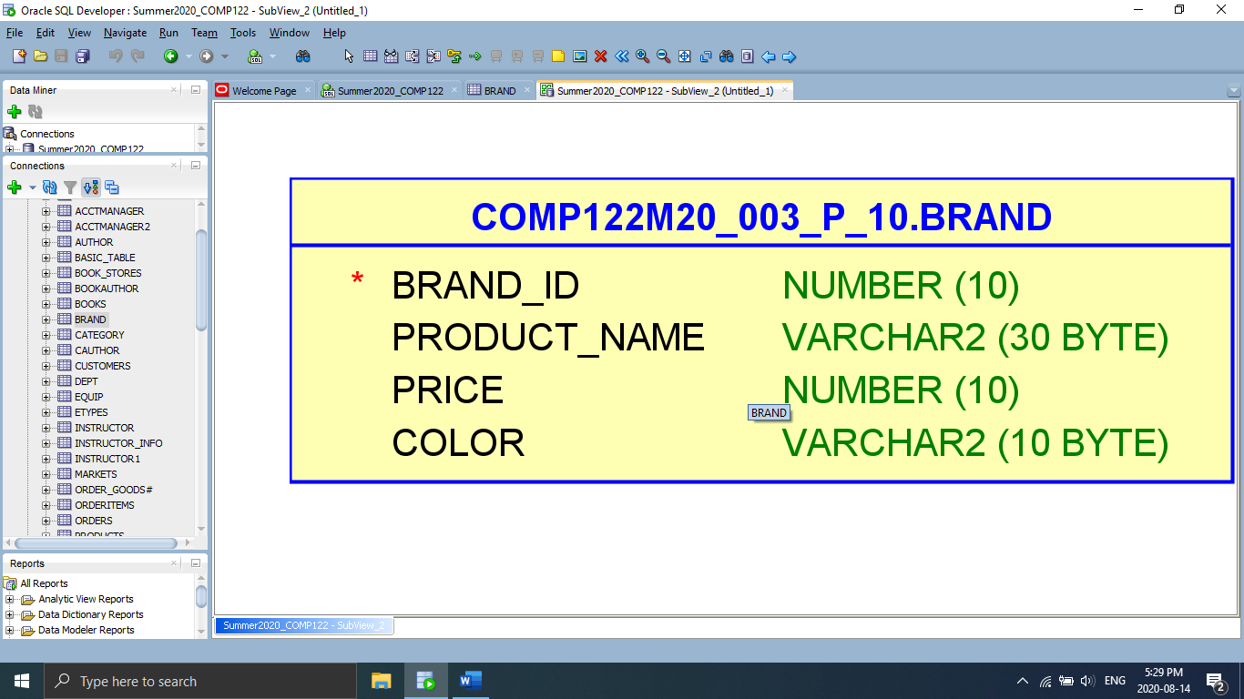

**Table: Suppliers**

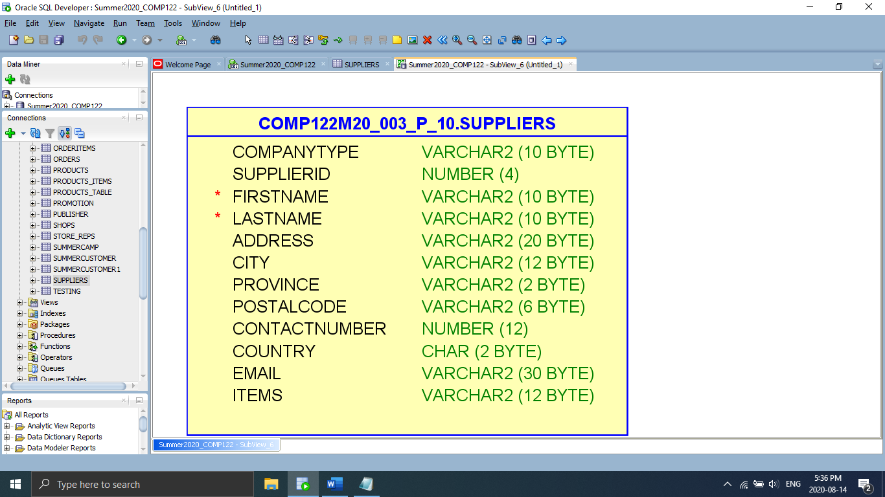

**Table: Markets**

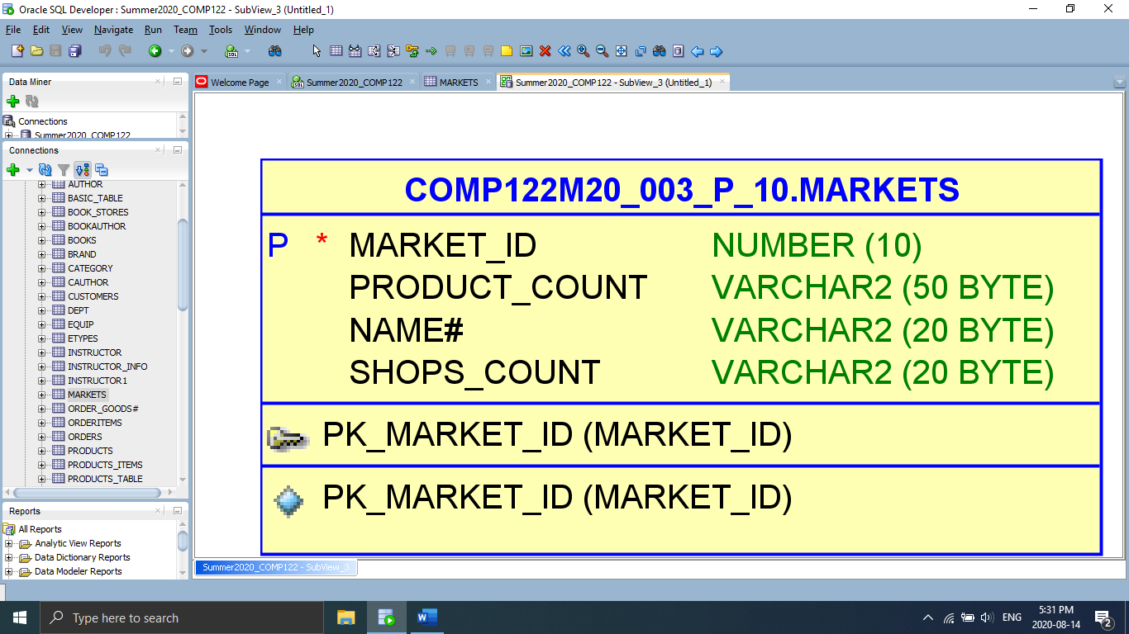

**Table: Products**

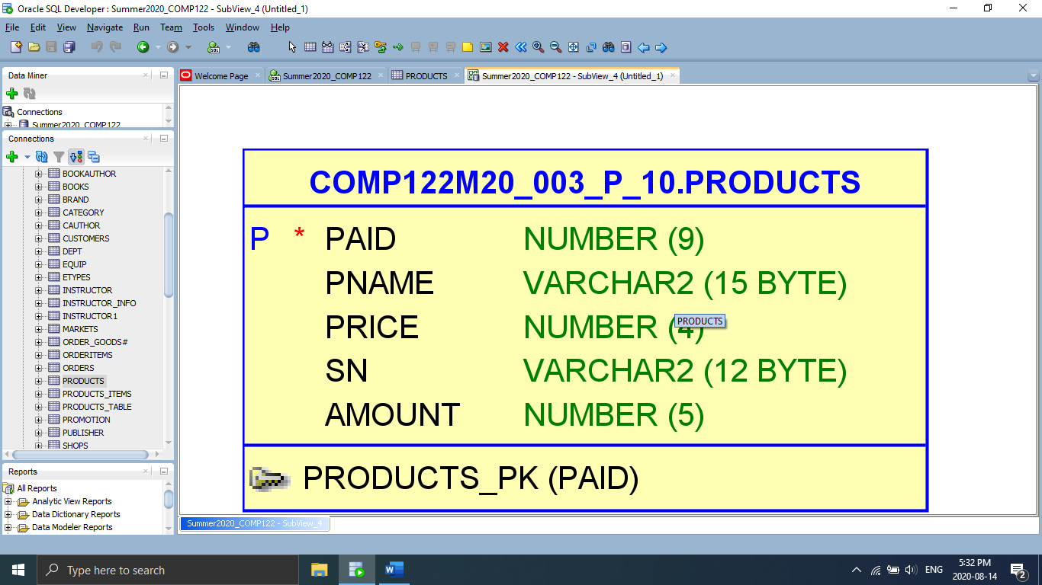

**Table: Shops**

